**E-MAIL CLIENT SOFTWARE**

Project submitted to the

SRM University – AP, Andhra Pradesh

for the partial fulfilment of the requirements to award the degree of

**Bachelor of Technology/Master of Technology**

In

**Computer Science and Engineering**

**School of Engineering and Sciences**

Submitted by

**Candidate details**

SAI HARSHITH TENNRI - AP21110010211

SRINIVAS PRADHAN - AP21110010220

GYANESH RAO - AP21110010239

ARADHY GARG - AP21110010241



Under the Guidance of

**Kavitha Rani**

**SRM University–AP**

**Neerukonda, Mangalagiri, Guntur**

**Andhra Pradesh – 522 240**

**[Month, Year]**

# Certificate

Date:05/12/22

This is to certify that the work present in this Project entitled “**EMAIL-CLIENT SOFTWARE**” has been carried out by **SAI HARSHITH TENNRI(AP21110010211), SRINIVAS PRADHAN(AP21110010220), GYANESH RAO(AP21110010239), ARADHY GARG (AP21110010241)** under my/our supervision. The work is genuine, original, and suitable for submission to the SRM University – AP for the award of Bachelor of Technology/Master of Technology in **School of Engineering and Sciences**.

## Supervisor

(Signature)

Prof. / Dr. Kavitha Rani

Designation,

Affiliation.

## Co-supervisor

(Signature)

Prof. / Dr. [Name]

Designation,

Affiliation.

**Table of Contents**

Certificate

Table of contents

Abstract

Introduction

Tools And Technologies Used

Source Code

Conclusion

# Abstract

Our advanced email client software revolutionizes the way you manage and interact with your email accounts. With a user-friendly interface and a range of powerful features, our software consolidates multiple email accounts, intelligently filters messages, and offers customizable templates. It seamlessly integrates with productivity tools, ensures security, and is accessible across various platforms. Experience improved organization, enhanced productivity, and efficient communication with our email client software.

# Introduction

An email client is a computer program that you can be used to send, receive, and manage your emails. It helps you organize and access your emails from different email accounts in one place. Outlook and Thunderbird are examples of email clients.

**Tools and Technologies Used**

* IDE – NetBeans
* Programming language – Java
* Database – Text Files
* GUI - Swing

**Source Code**

Login :

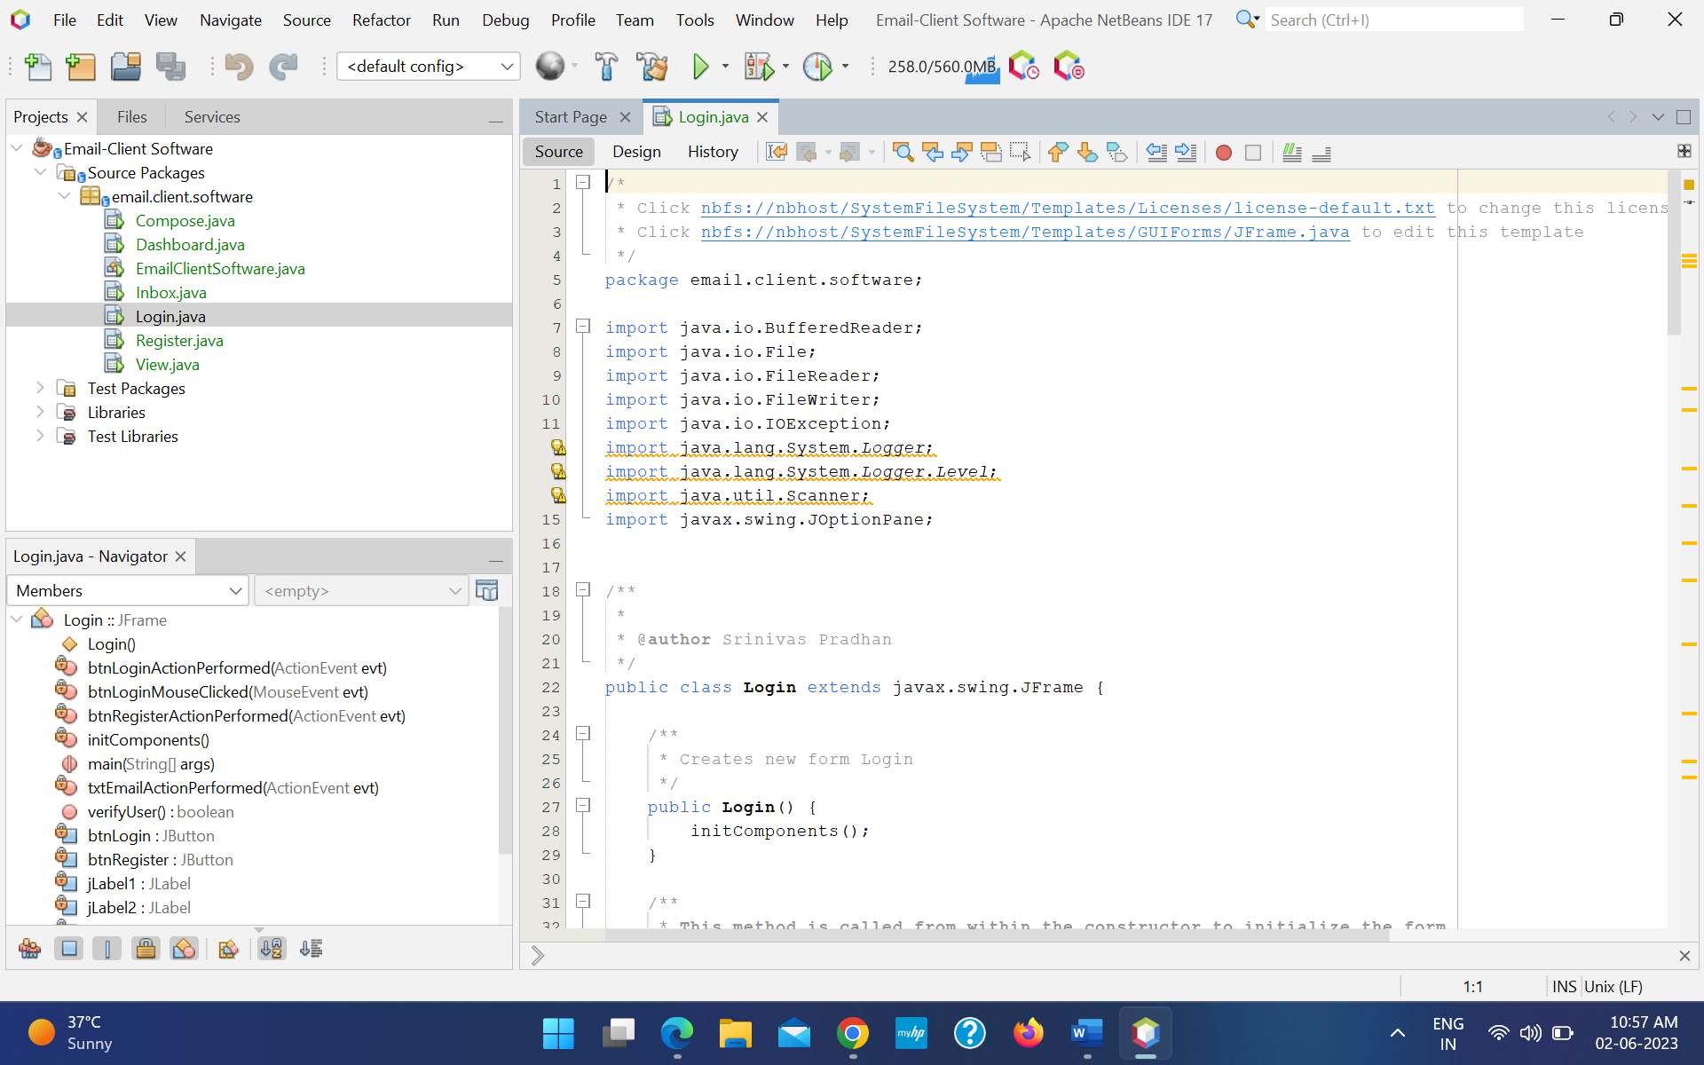

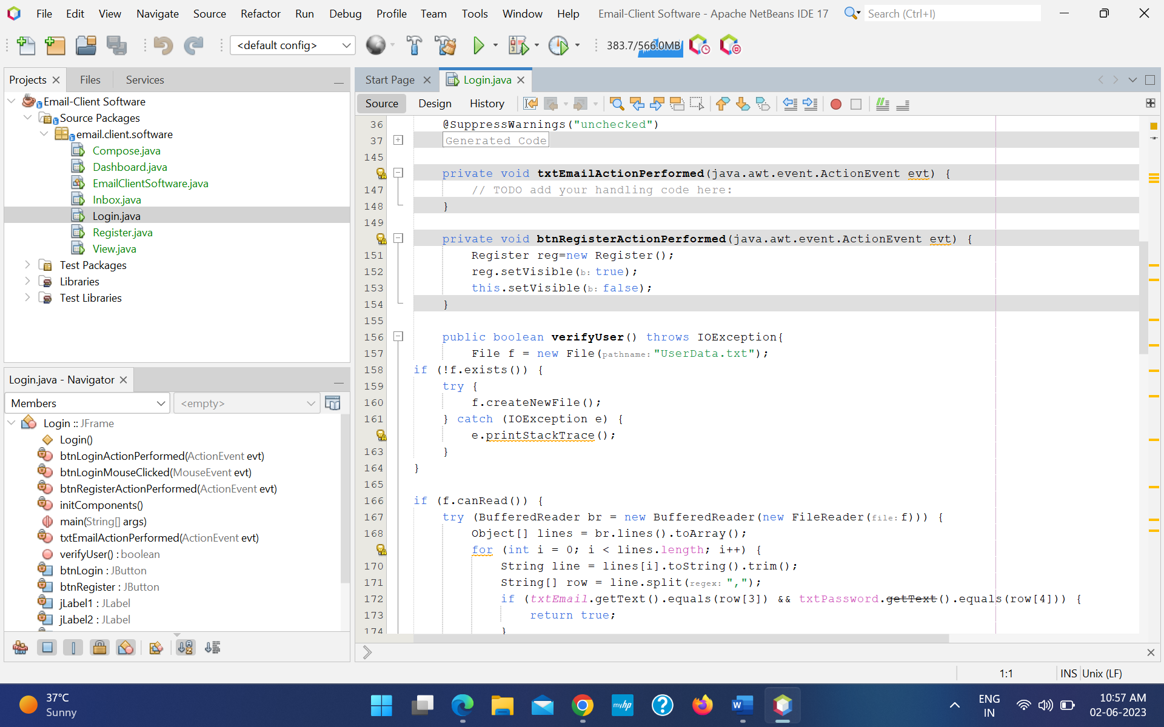

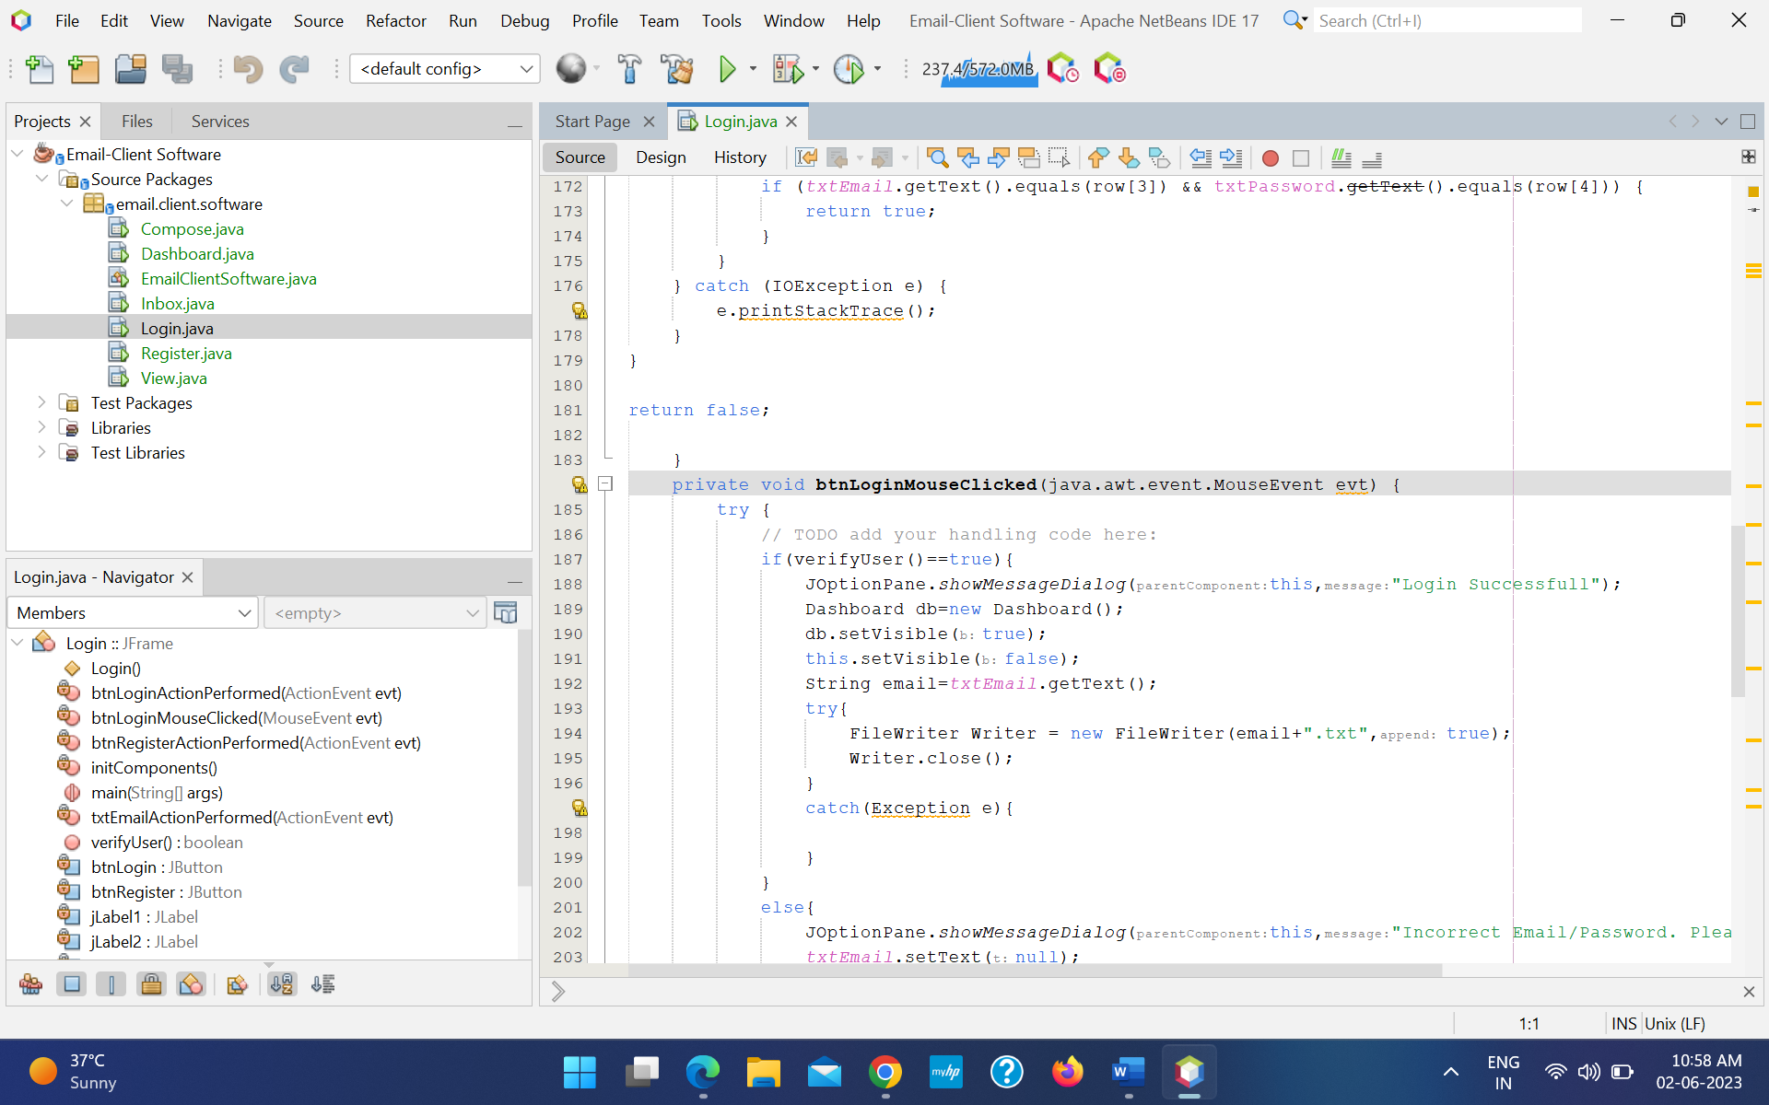

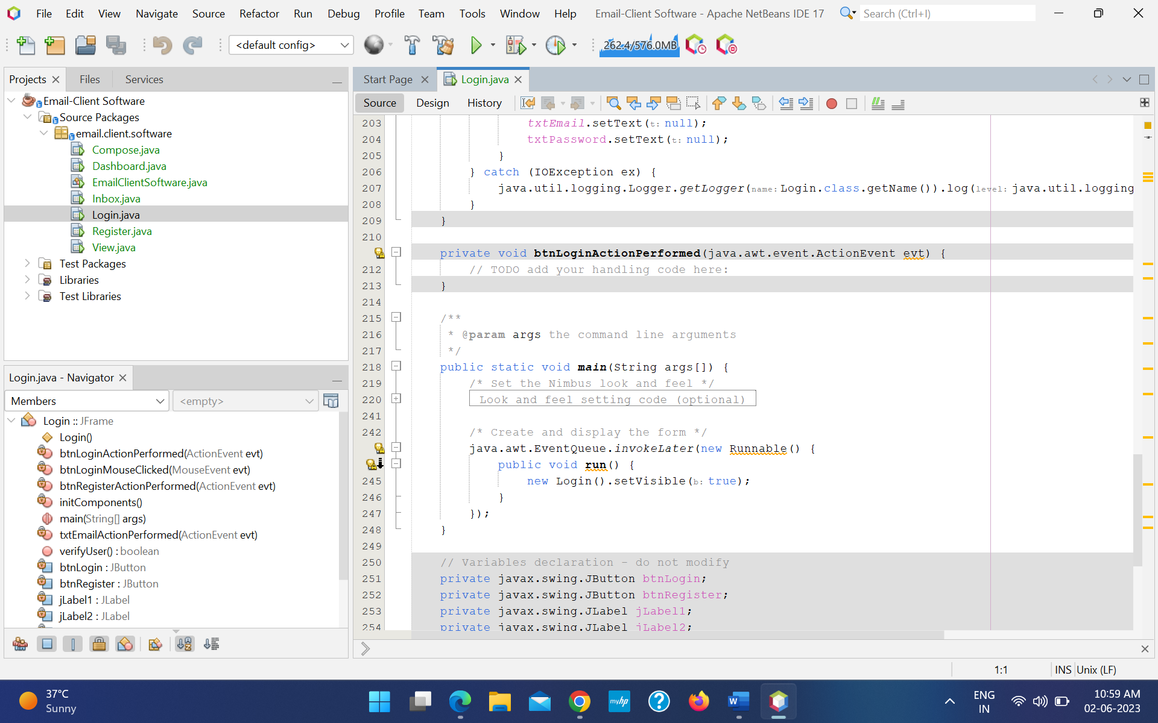

Register :

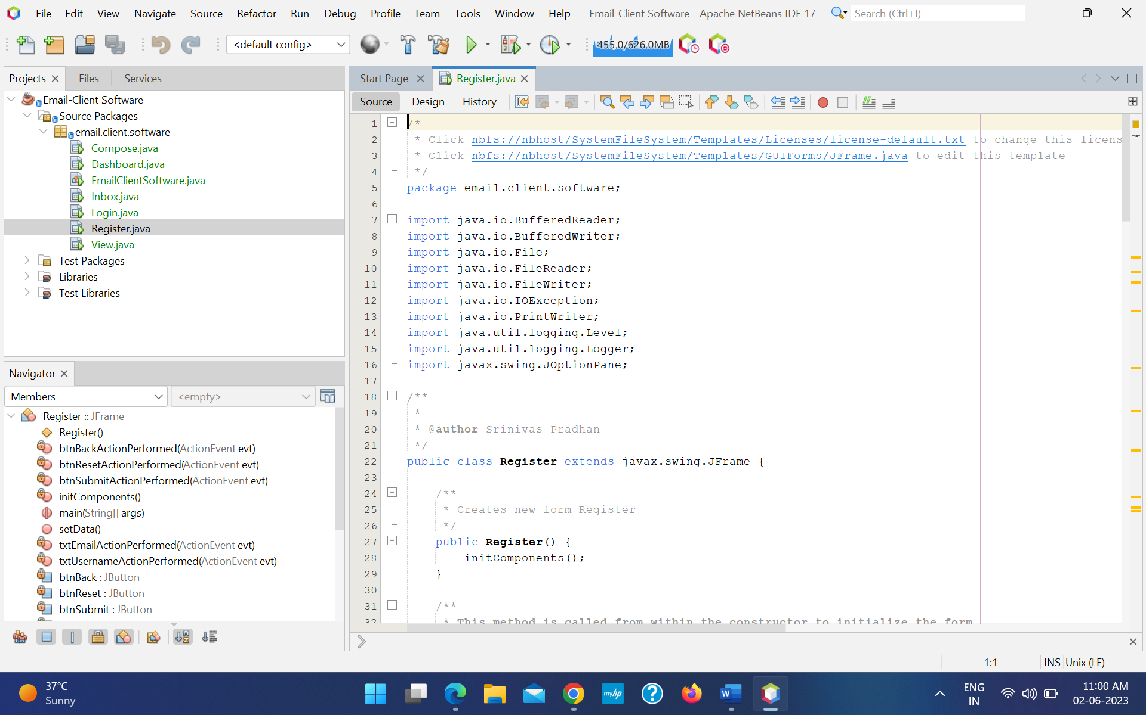

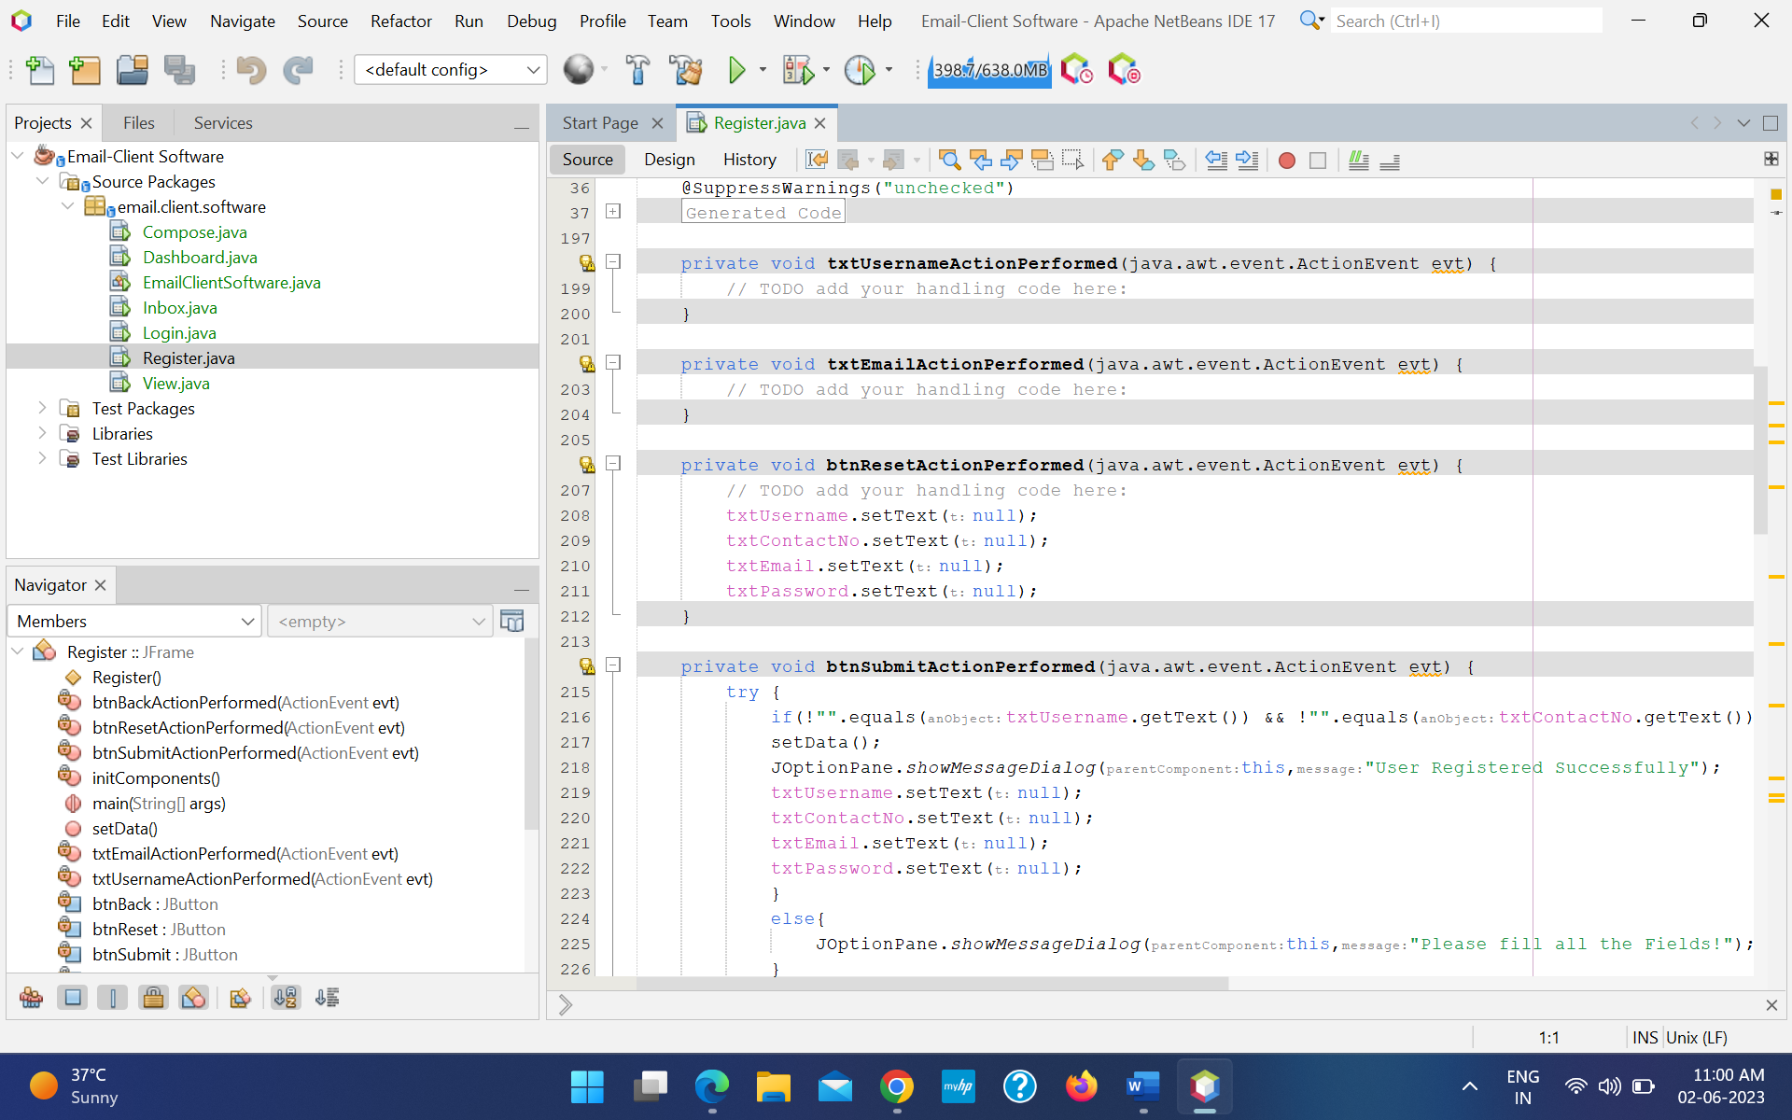

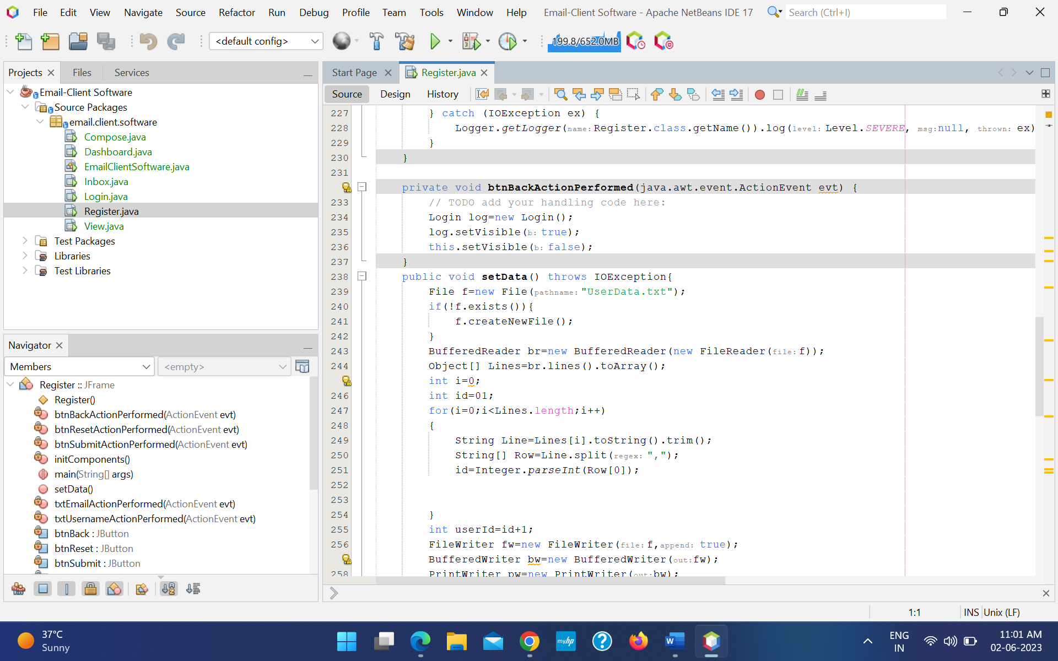

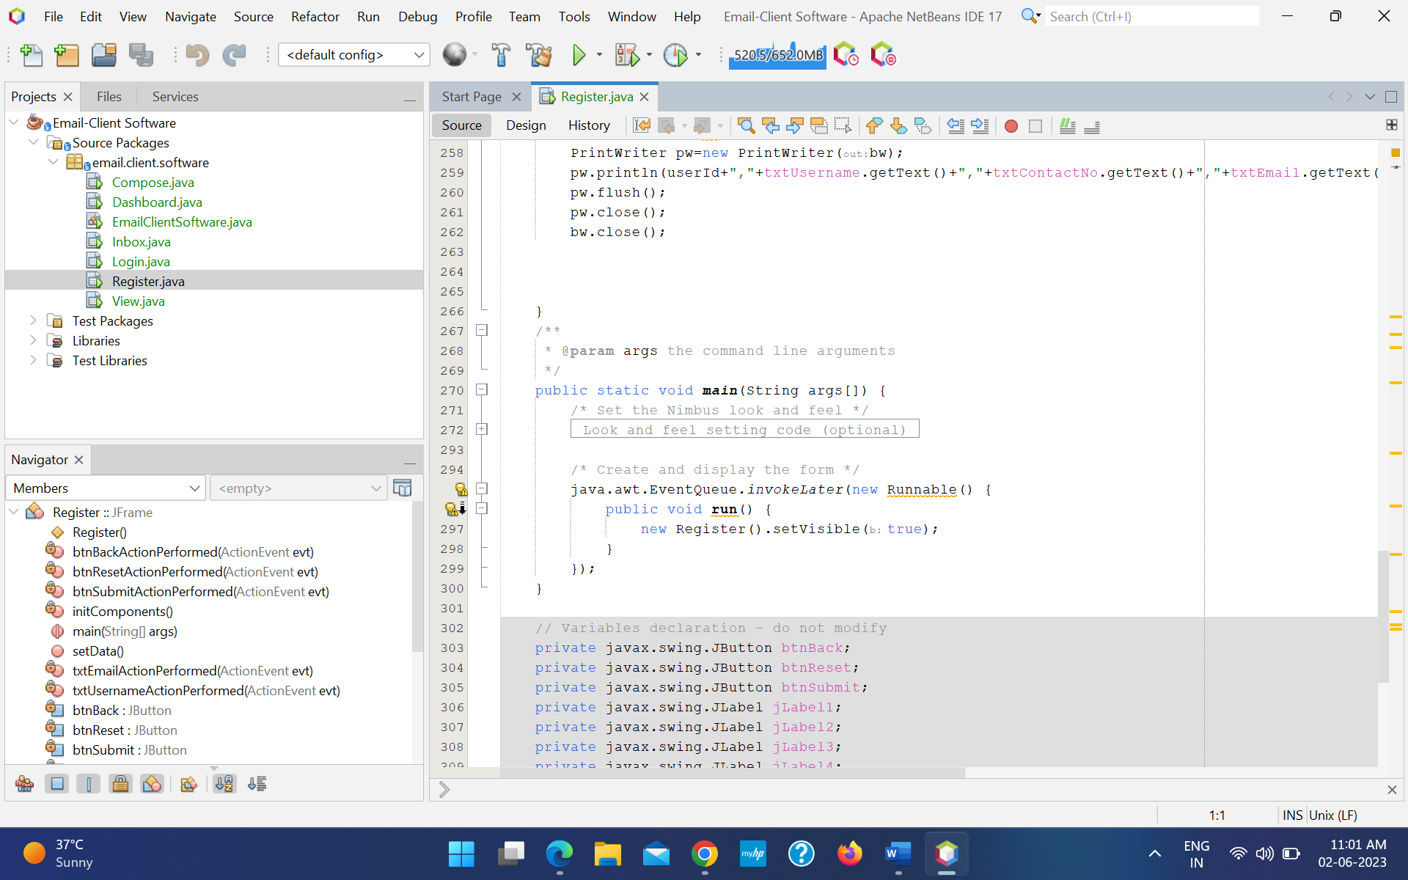

Dashboard :

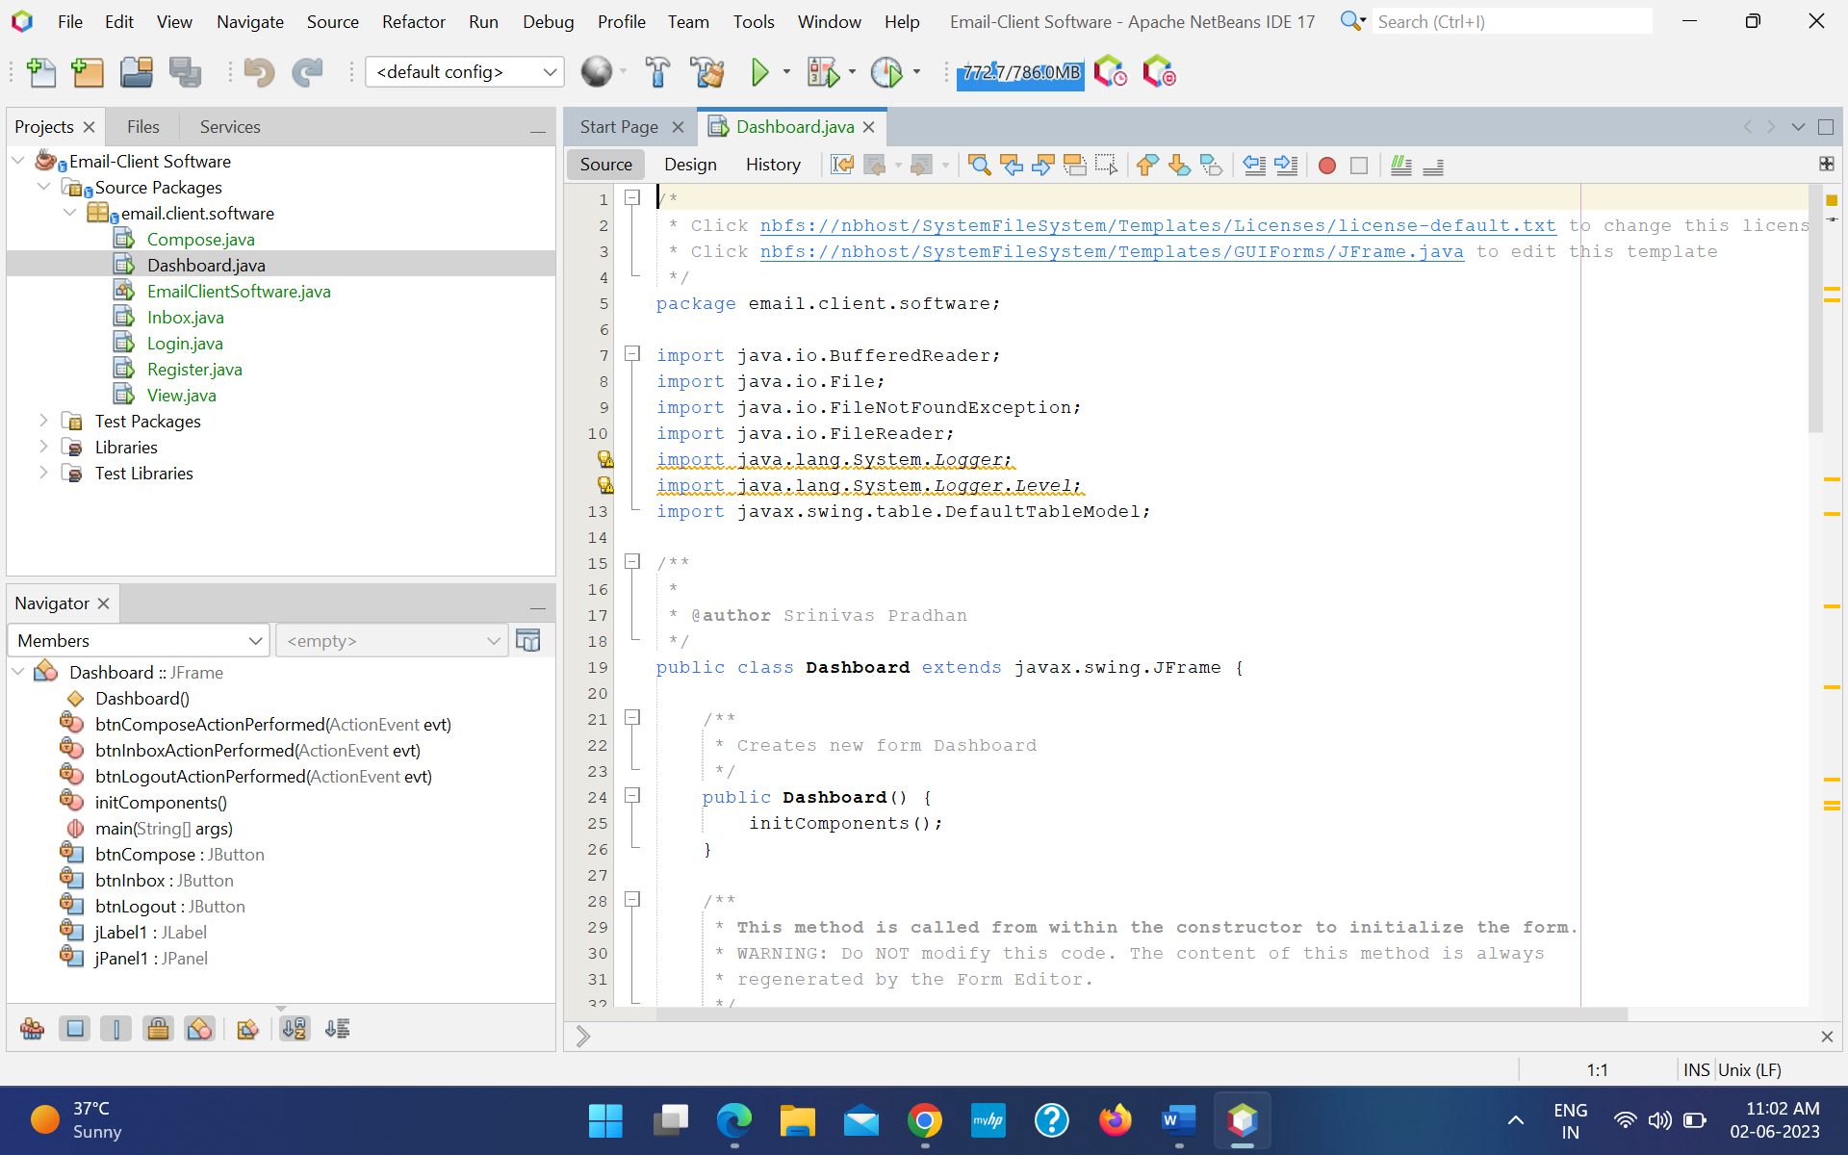

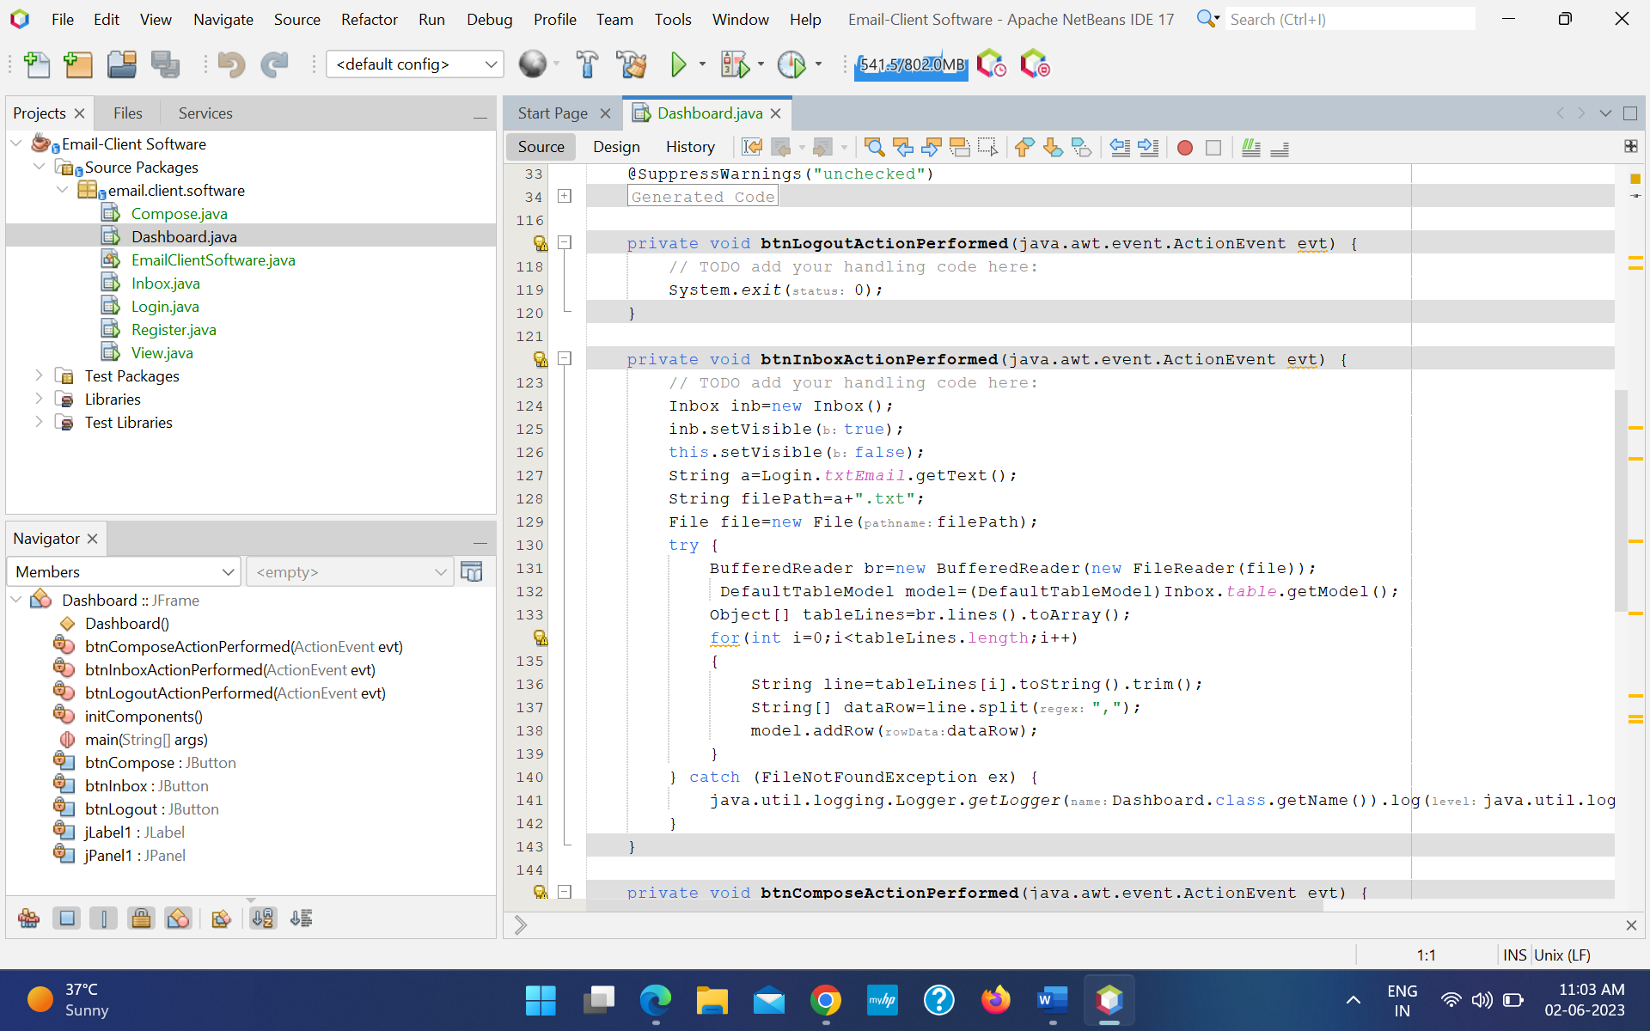

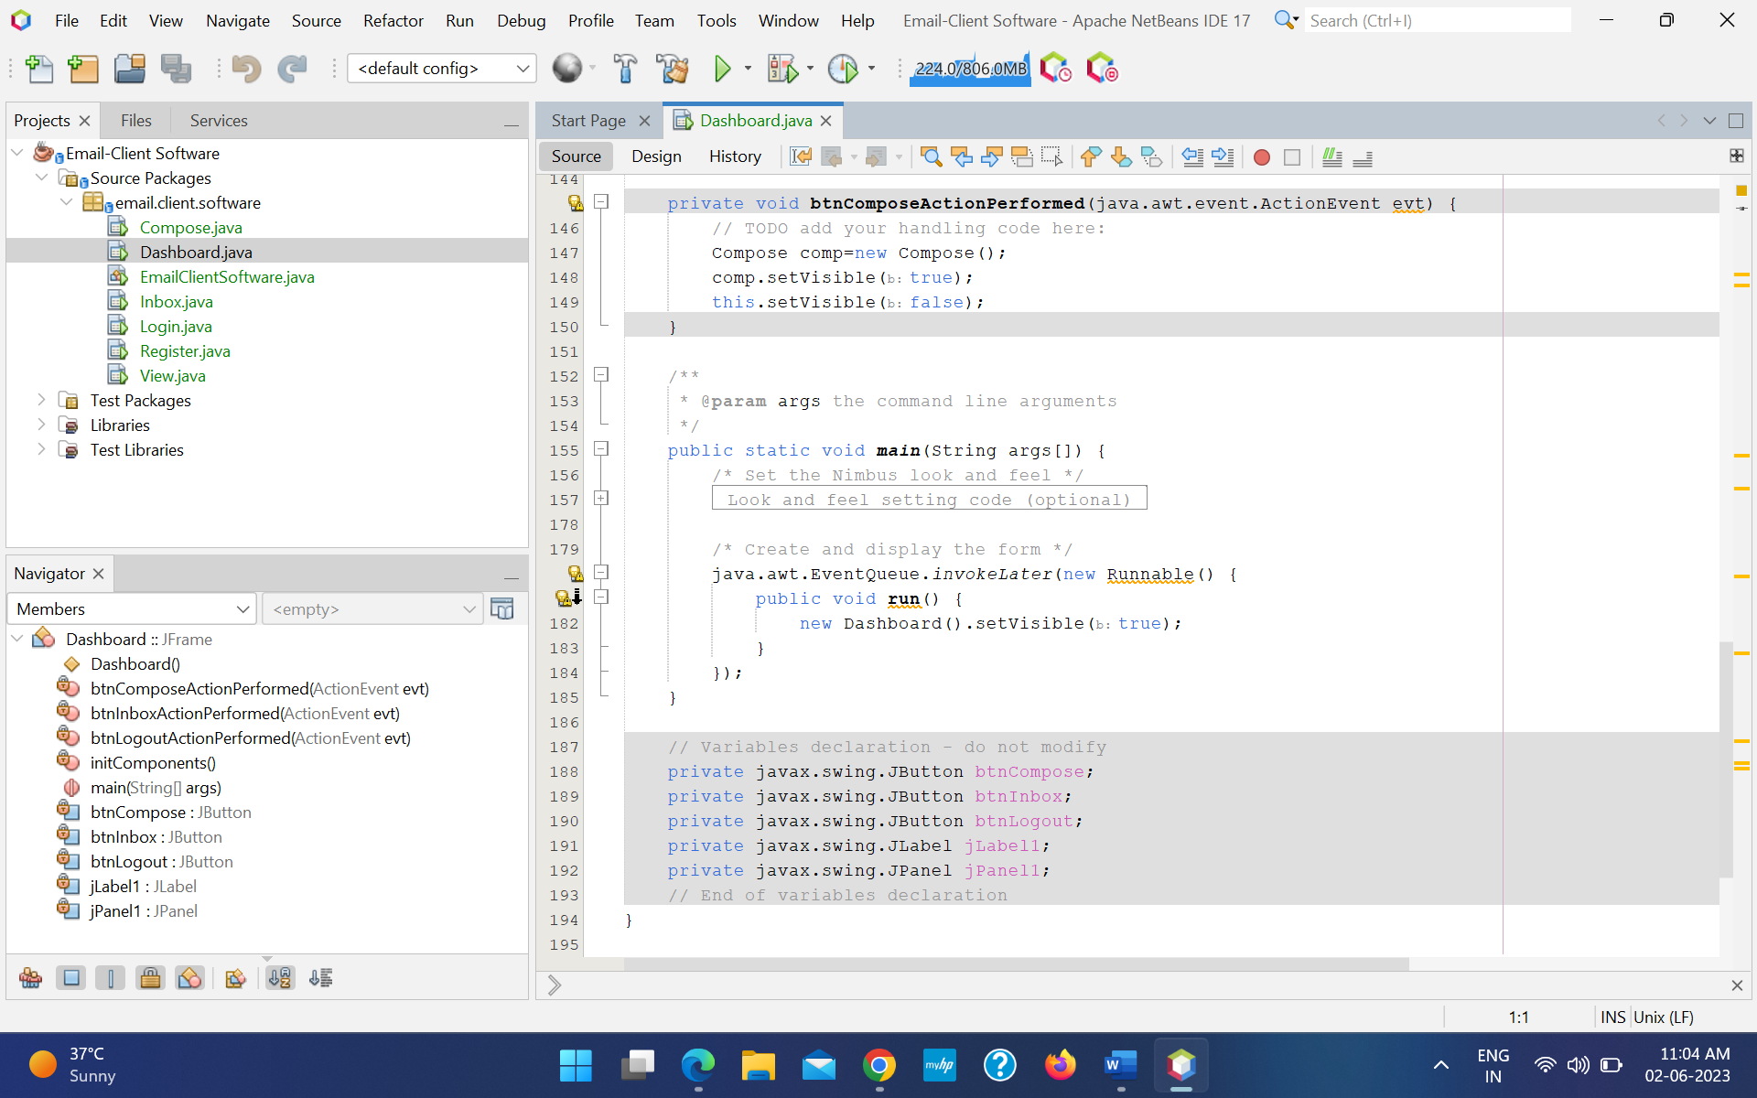

Inbox :

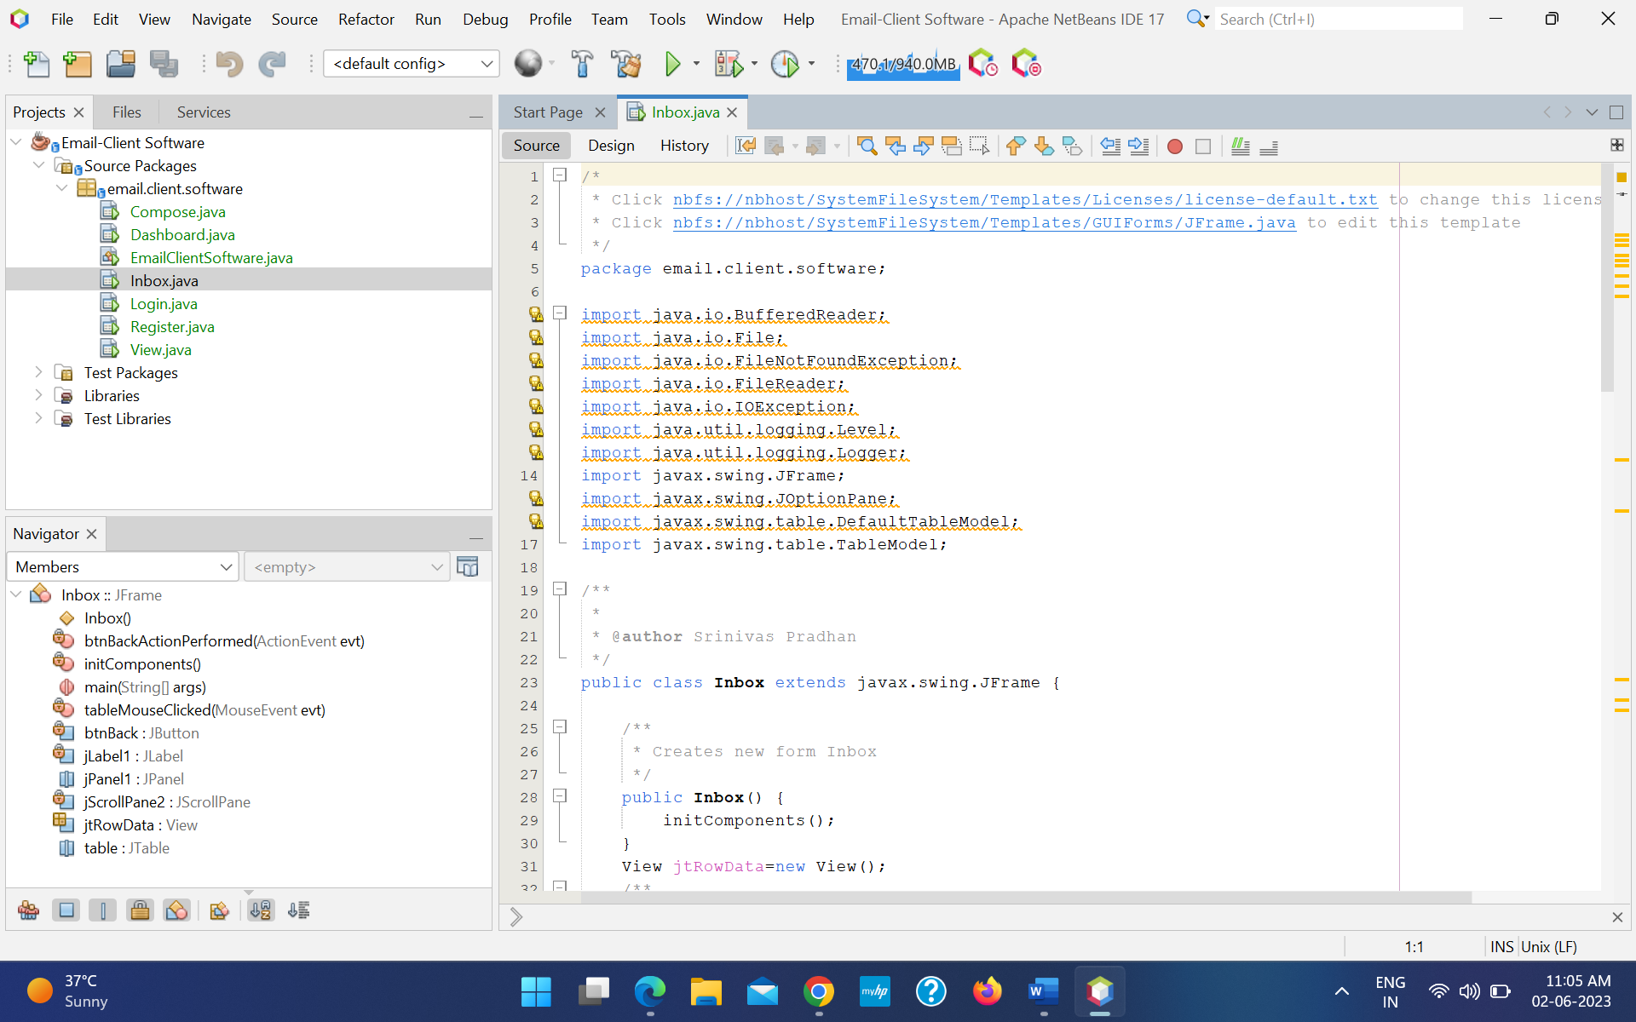

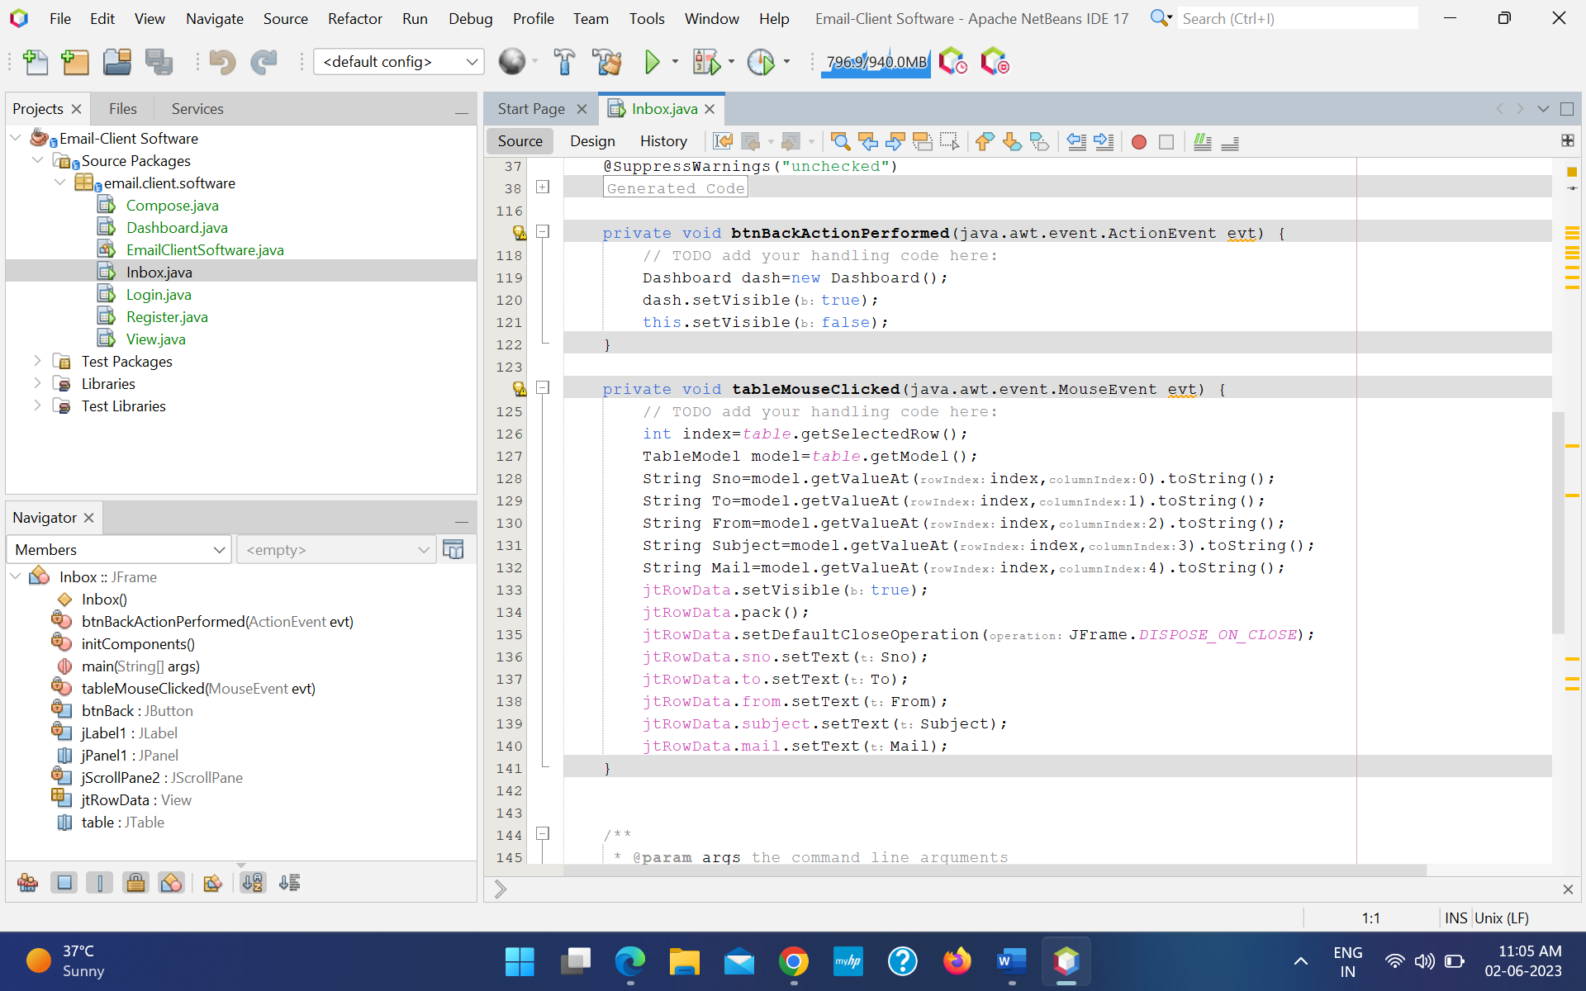

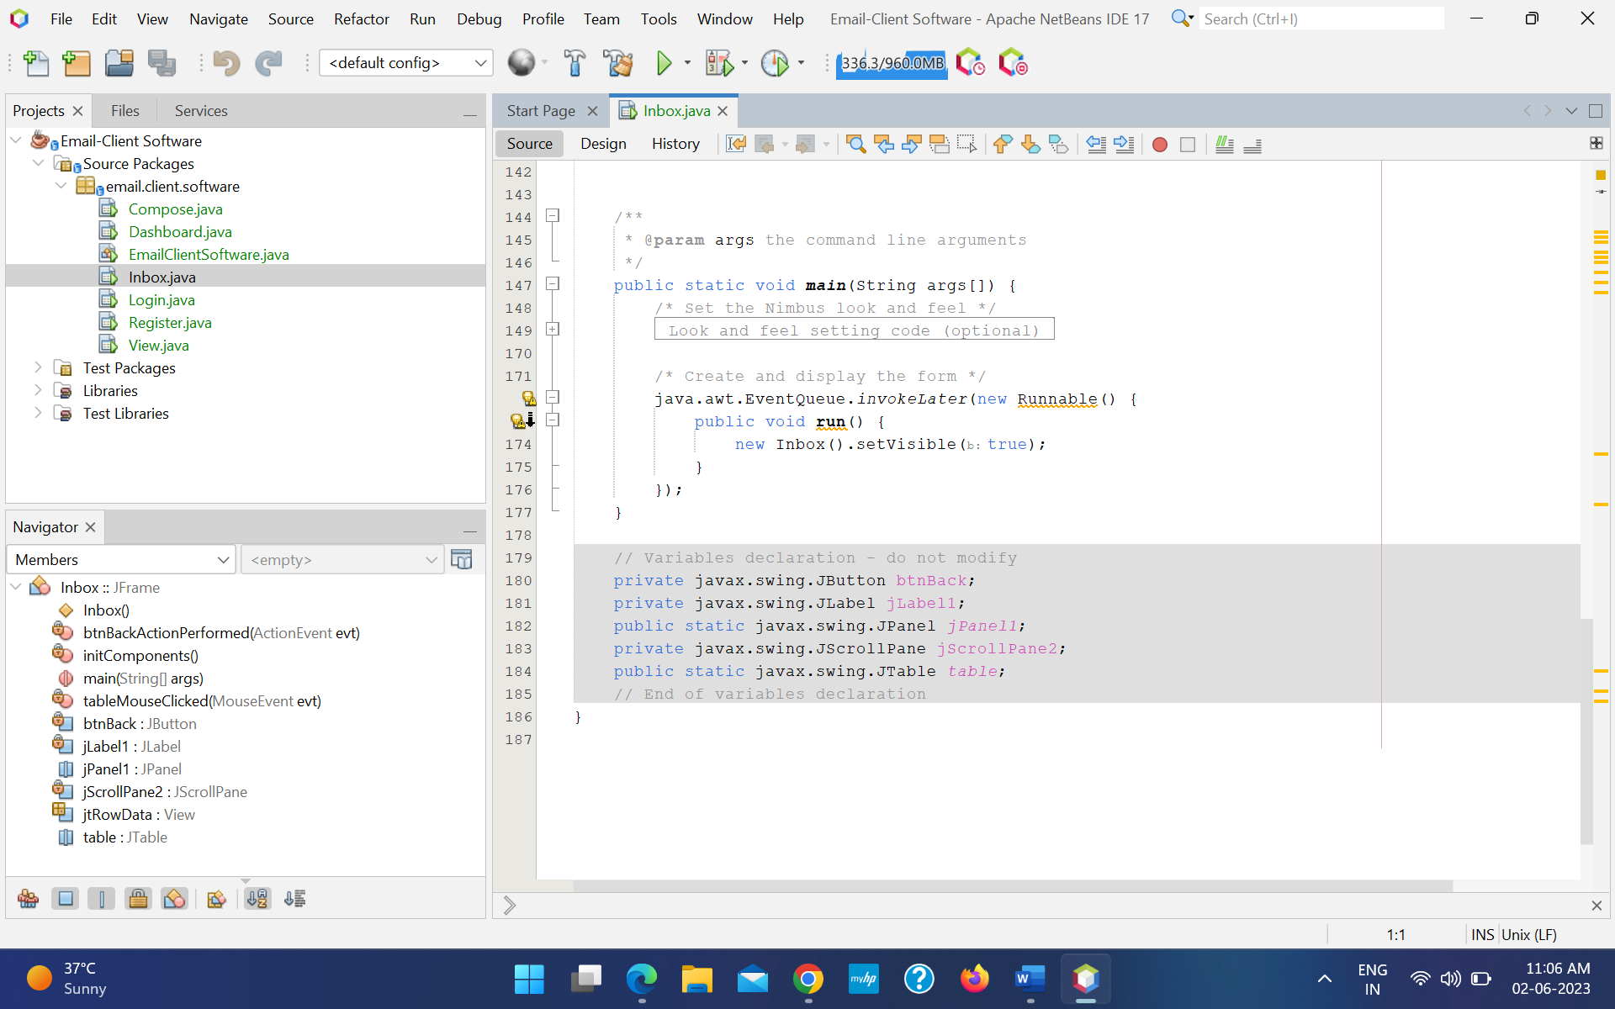

Compose :

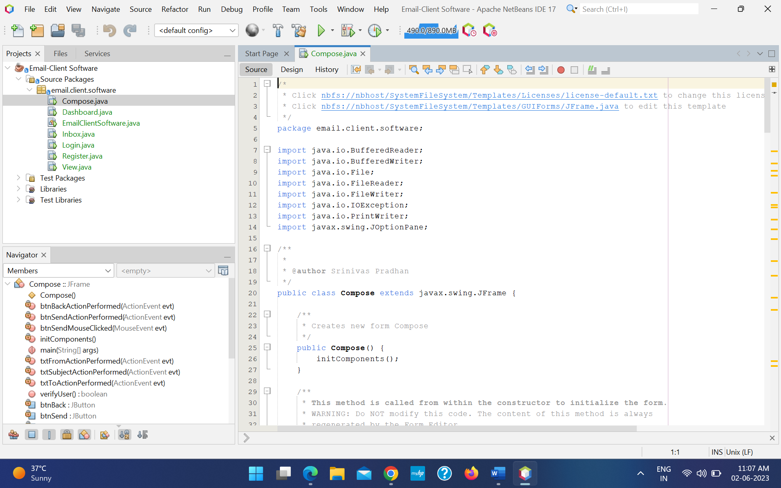

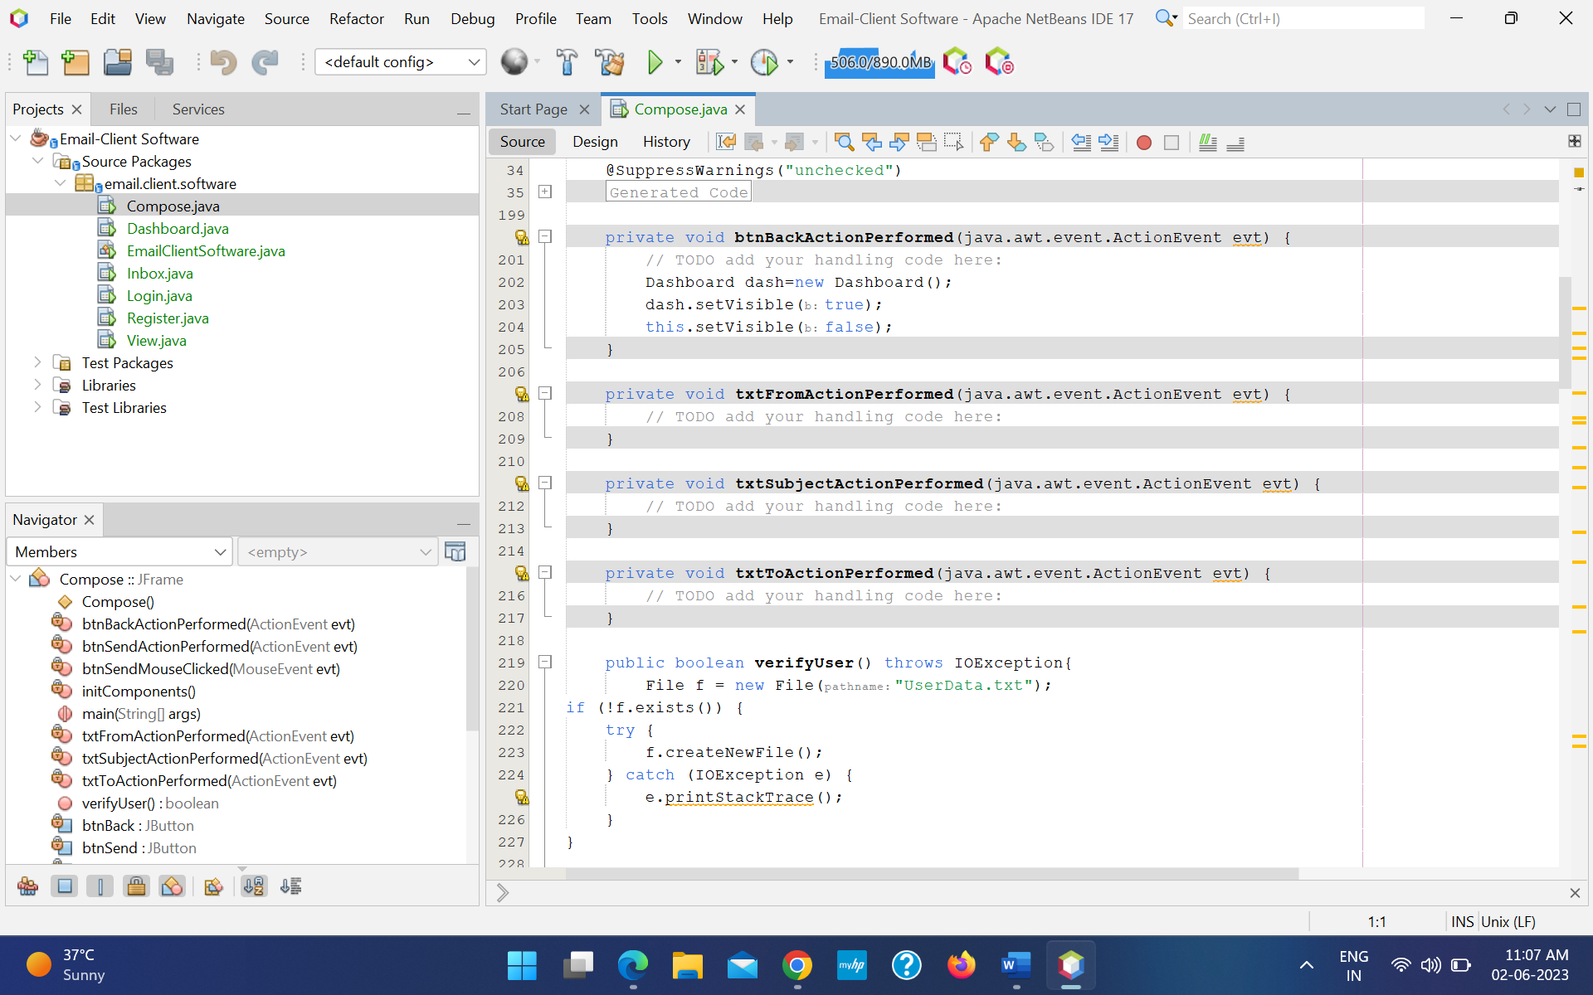

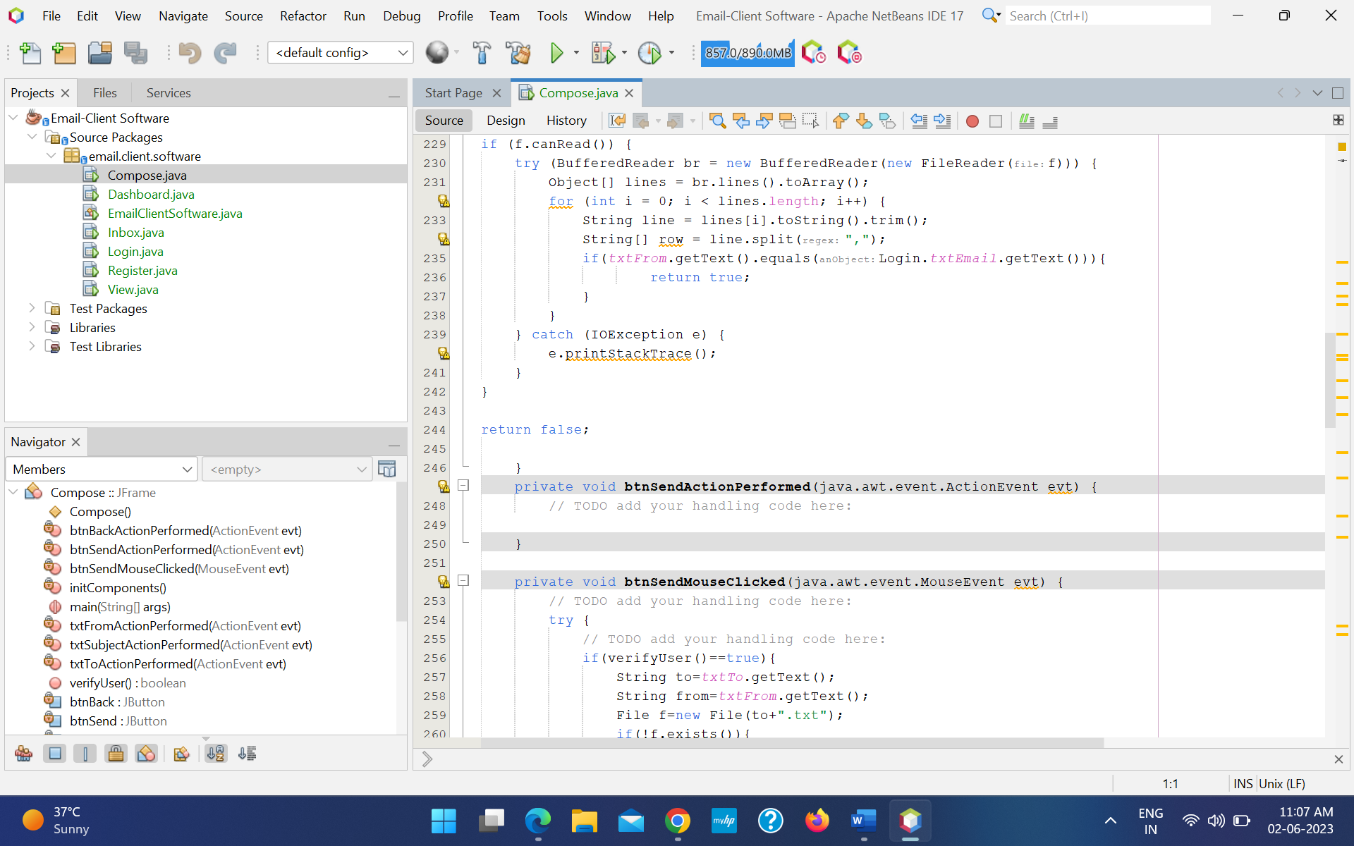

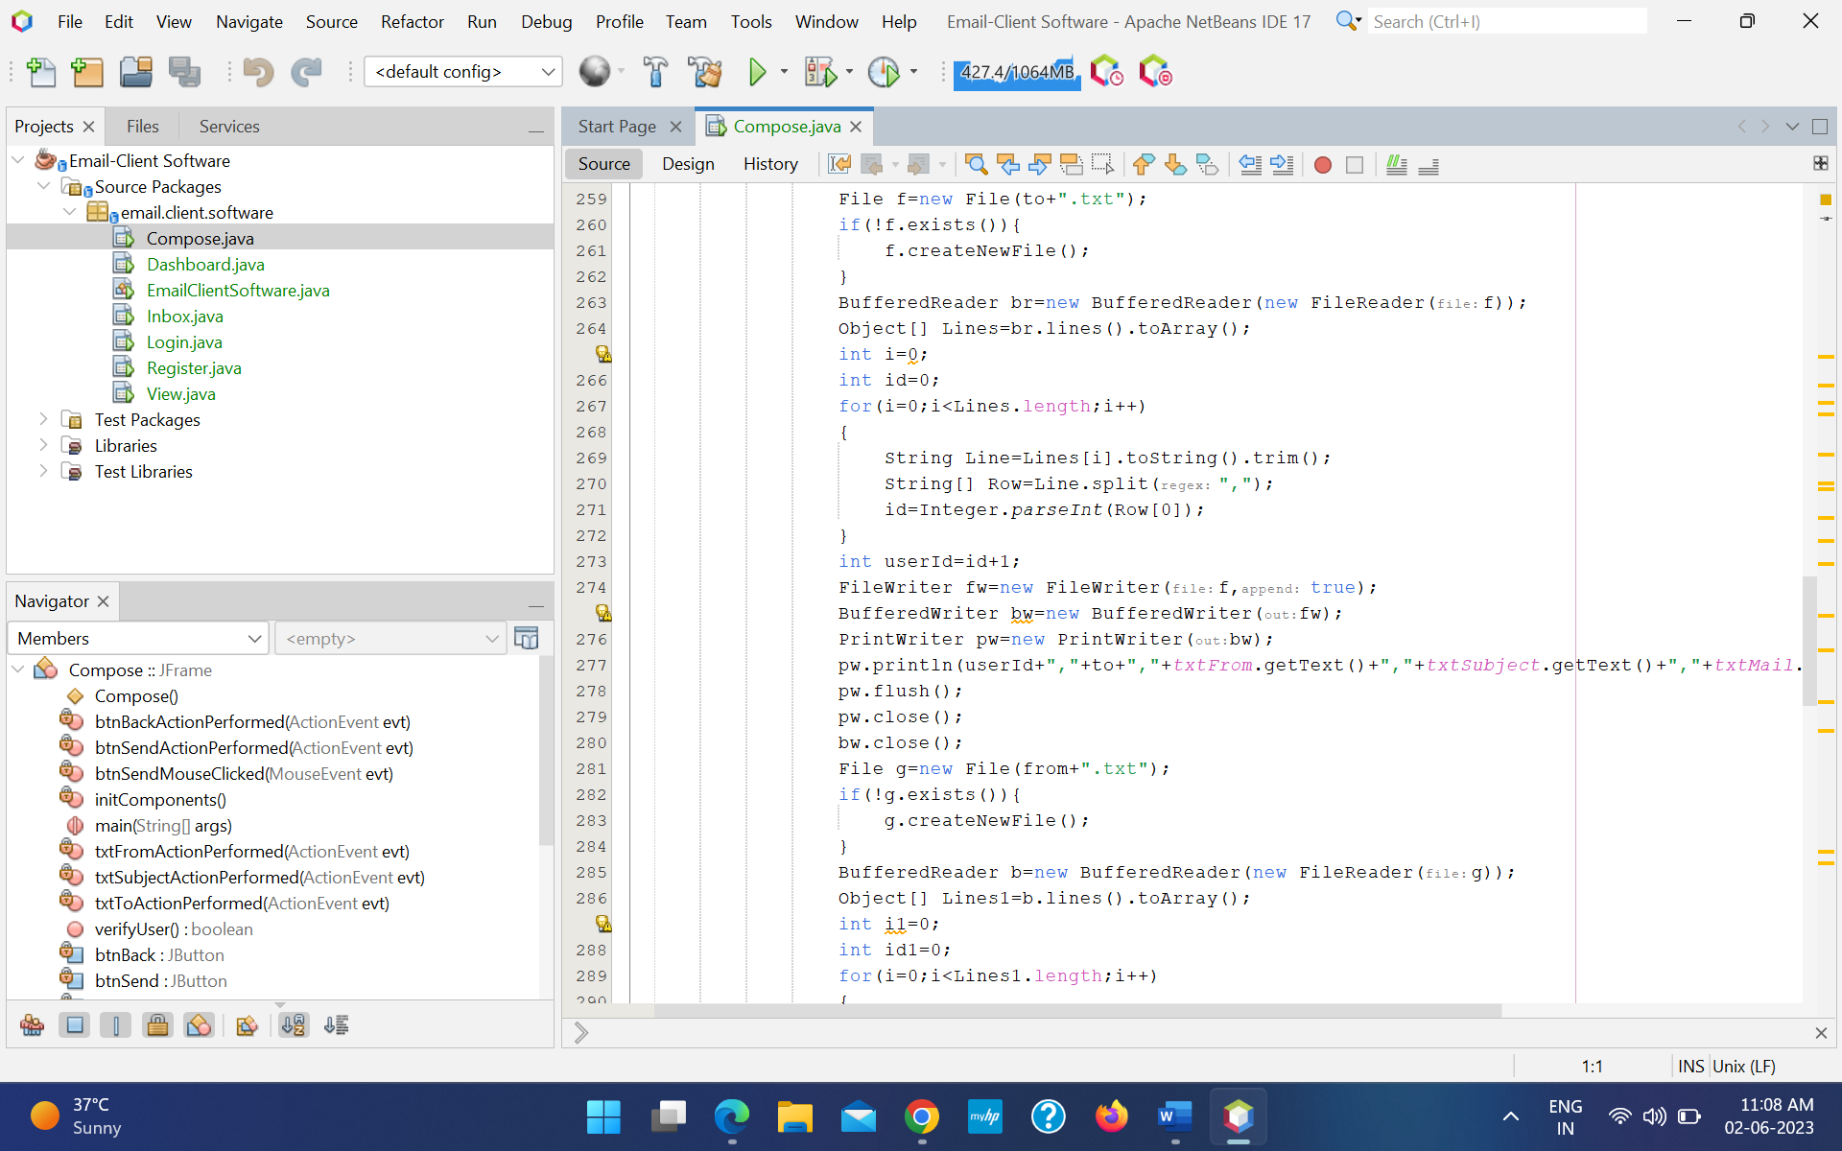

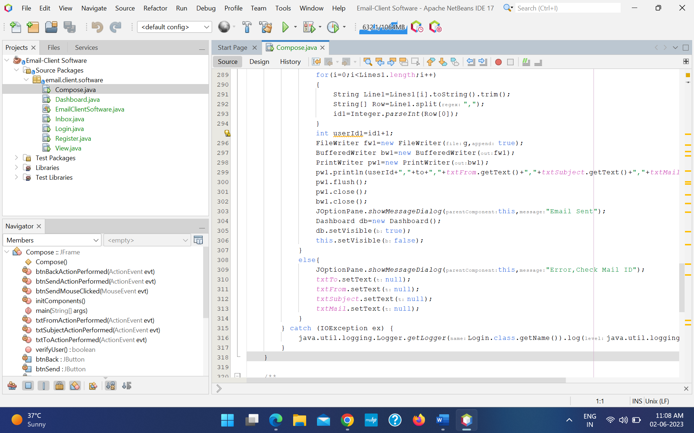

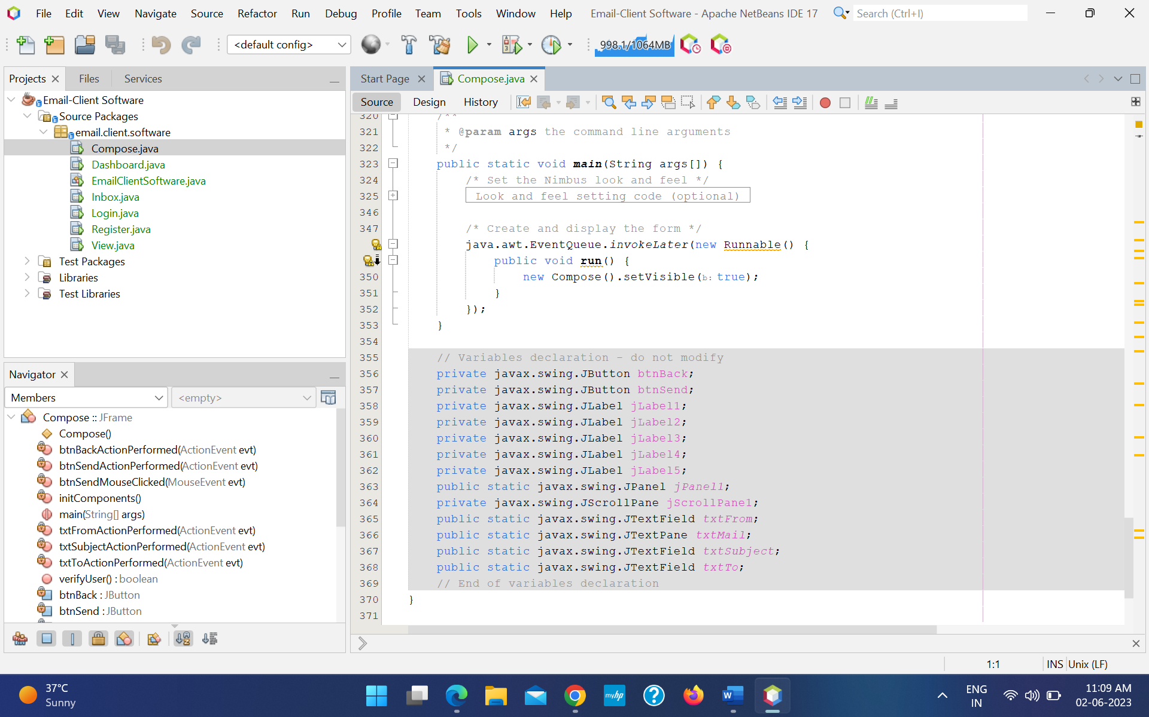

View :

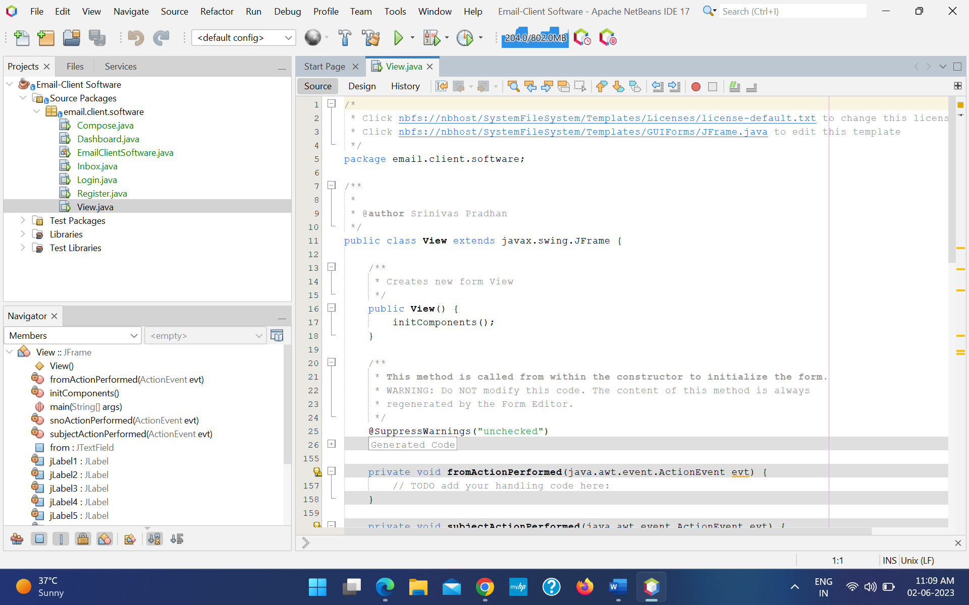

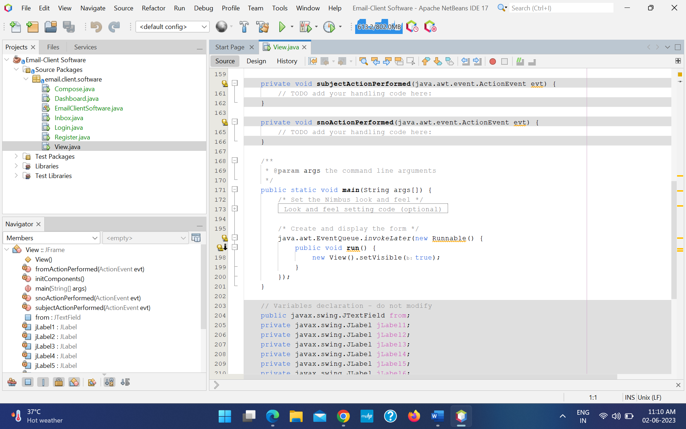

**Conclusion**

In conclusion, the Java-based email client software project successfully implements essential features for efficient email communication and management. It showcases the students' skills in Java programming, user interface design, network communication, and application testing. The software offers a userfriendly interface, supports multiple email protocols, and prioritizes security considerations. Overall, the project provides valuable learning experience and contributes to enhancing email communication.